Introduction
The Strategic Transportation Investments (STI) law is the formula to determine how the North Carolina Department of Transportation (NCDOT), in partnership with local governments, will fund and prioritize transportation projects in the state of North Carolina. Under this formula, all modes will compete for the same funding based on a data driven process called Prioritization. The Strategic Transportation Investments places projects into three categories: Statewide, Regional and Division levels. The Statewide level is based solely on quantitative data such as benefit cost and safety ratios. Metropolitan Planning Organizations (MPOs), Rural Planning Organizations (RPOs) and Division Engineers will assign local input points to projects in the Regional and Division levels. These points will be included in the calculation of the final project scores for Prioritization 5.0 (P 5.0) for the Regional and Division categories. MPOs and RPOs are required to develop methodology for the assignment of local input points and NCDOT must approve this methodology.

Each of the three funding categories identified under the new Strategic Transportation Investments have their own criteria.

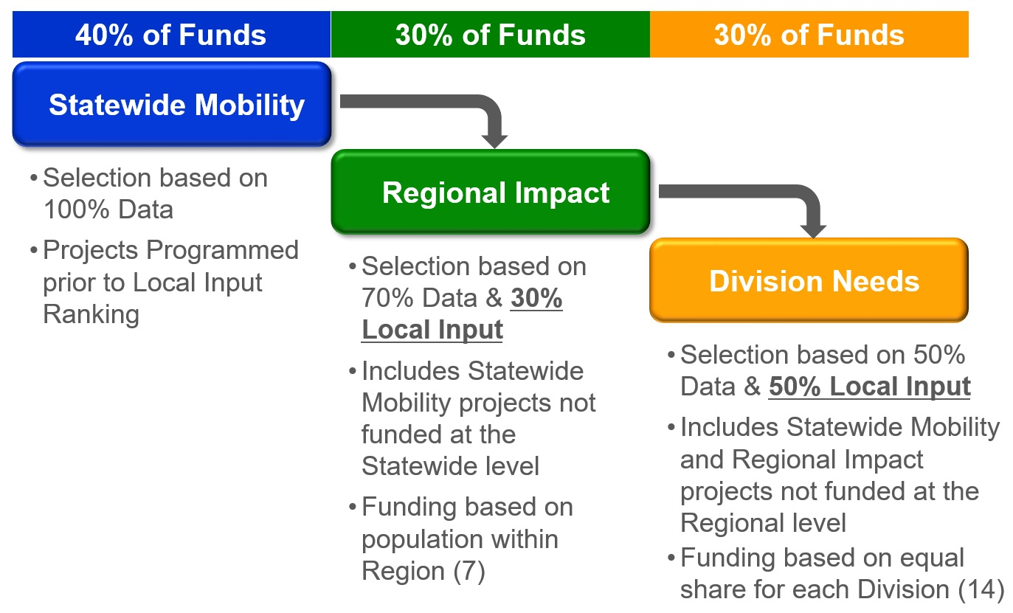

This methodology is intended to ensure a process that is both data-driven and responsive to local needs. The methodology has been developed to meet the requirements of Session Law 2012-84 (Senate Bill 890), which requires that MPOs and RPOs have a process that includes at least two criteria, with at least one being qualitative, for determining project prioritization. The following methodology has been developed by the Wilmington Urban Area MPO for the purposes of determining transportation funding priorities for Prioritization 5.0.

The WMPO’s participation in the Strategic Transportation Investments consists of the following steps:
- Selection of projects for consideration in the Statewide, Regional and Division levels;
- Receive quantitative scoring of submitted projects that has been determined by NCDOT’s Strategic Prioritization Office of Transportation (SPOT);
- Develop draft qualitative scoring of projects and ranking;
- Public involvement process; and
- Finalize project scoring and ranking.

Each level of criteria is listed below:

Statewide Level (40% of total revenue funding)
- Projects of statewide significance will receive 40% of the available revenue funding.
- The project selection process will be 100% data-driven/quantitative scoring.

Regional Level (30% of total revenue funding)
- Projects of regional significance will receive 30% of the available revenue funding based on regional population. Projects on this level compete within specific regions made up of two NCDOT Divisions. The Wilmington MPO is located in Region B, made up of Divisions 2 and 3.
- Data/ quantitative scoring will comprise 70% of the decision-making process and local rankings will comprise of the remaining 30%. This 30% local input will be shared 15% by the Division Engineers and 15% MPO/RPO input.

Division Level (30% of total revenue funding)
- Projects that address local concerns such as safety, congestion and connectivity will receive 30% of the available revenue funding shared equally over NCDOT’s 14 Transportation Divisions. The Wilmington MPO is located in NCDOT Division 3.
- The Department will choose projects based 50% on data and 50% on local rankings. This 50% local input will be shared 25% by the Division Engineers and 25% MPO/RPO input.

NCDOT Divisions
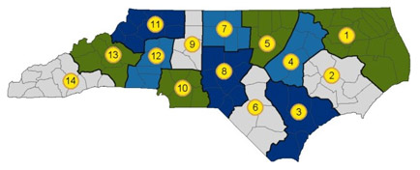

The North Carolina Department of Transportation will be developing quantitative scores for all projects based on adopted criteria from the P5.0 Workgroup.

Description of Criteria and Weights
While developing the Cape Fear Transportation 2040 Transportation Plan, the Wilmington Urban Area MPO’s Board utilized a prioritization process for evaluating projects identified in the plan. Projects included in Cape Fear Transportation 2040 have been prioritized for a limited amount of funding from the fiscally-constrained funding sources. The MPO used both quantitative (objective) and qualitative (subjective) information to determine which projects represented the greatest need to match available funding sources within its boundaries. Members of the general public, elected officials, subject matter experts and planning technicians within the Wilmington Urban Area submitted project proposals for 6 modes of transportation – Aviation, Bicycle and Pedestrian, Ferry and Water Transportation, Freight and Rail, Mass Transportation, and Roadways.

All projects were evaluated using goals and objectives identified for each mode. A ranked list of projects was then used as the basis for the fiscal constraint analysis determining which projects could receive a portion of the anticipated funding in this region between 2015 and 2040.

The MPO proposes to utilize the following as evaluating criteria in assigning the local input points: the Prioritization 5.0 Quantitative Score, Wilmington MPO’s Prioritization 4.0, Consistency with Plans, Status of Project in Development, and Inclusion in Adopted Strategic Business Plan. The WMPO will use the quantitative P 5.0 scores from NCDOT as part of the prioritization process as well as to guide the Board in the assignment of local input points.

The Local Input is the priority of the project as ranked by the Technical Coordinating Committee (TCC) and MPO Board. The Board will review and approve a final prioritized list of projects for submission to SPOT. A matrix will be used to develop the draft Local Input points. Below please find an example of this matrix:

 | Prioritization 5.0 Quantitative Score | Wilmington MPO’s Prioritization 4.0 | Consistency with Plans | Status of Project in Development | Inclusion in Adopted Strategic Business Plan | Total
 | Points  (x of 100) | Points (x of 100) | Points (x of 100) | Points (x of 100) | Points  (x of 100) | Points (x of 500)
Project X

Prioritization 5.0 Quantitative Score- The Prioritization 5.0 Quantitative score is the score provided by SPOT for each project. The MPO will convert the data/quantitative based Regional and Divisional level scores to a 100 point scale.

Prioritization 4.0 Points- the amount of local input points the project received during the Prioritization 4.0. This could range from 100 to 0.

Consistency with Plans- This criterion is used to determine if the proposed project is in an adopted plan. Each project will be evaluated with the points assigned as follows:

- Projects included in the adopted Long Range Transportation Plan- 100 points
- Projects included in Plans adopted by the MPO- 50 points
- Projects that are adopted in plans by member jurisdictions and NCDOT but not adopted by the
MPO- 25 points

Status of the Project in Development- This criterion will identify which phase the project is in development. Each project will be evaluated with the criteria as outlined below:

- Projects that are in the right-of way acquisition or property already acquired by the State of North Carolina- 100 points
- Projects that are in the Design phase (engineering, construction document preparation, or surveying)- 50 points
- Projects that are in the Planning phase (feasibility study or environmental permitting/permitting phases)- 25 points

Inclusion in the adopted Strategic Business Plan – On February 22, 2017, The MPO’s Board adopted the 2017-2021 Strategic Business Plan. This plan highlights the Board’s top targets, objectives, and strategies. This criterion will award points to projects named within the adopted 2017-2021 Strategic Business Plan. Projects will be assigned points as follows:

- Project included in the adopted 2017-2021 Strategic Business Plan – 100 points
- Project is not included in the adopted Strategic Business Plan – 0 points

Total Score and Project Ranking

Utilizing the matrix and criteria scoring, all modes will compete against each other for funding. Below is an example of how a project is scored utilizing this method. The assignment of local input points will be based on a mathematical sum of the points assigned during the Local Input Methodology Process.

Example:

Project X is a widening project that includes two transit stop shelters, a bike lane, and 5’ sidewalks on both sides of the street. The project is a carryover from Prioritization 4.0, was awarded 50 local points, and recently received a Prioritization 5.0 quantitative score of 56.8. The project is in the design phase and is a supported project within the current adopted MTP. The project is not included in the currently adopted 2017-2021 Strategic Business Plan.

Utilizing the scoring method outlined previously, the following is a breakdown of the point assignment for Project X:

 | Prioritization 5.0 Quantitative Score | Wilmington MPO’s Prioritization 4.0 | Consistency with Plans | Status of Project in Development | Inclusion in Adopted Strategic Business Plan | Total
 | Points  (x of 100) | Points (x of 100) | Points (x of 100) | Points (x of 100) | Points  (x of 100) | Points (x of 500)
Project X | 56.8 | 50 | 100 | 50 | 0 | 356.8

Each MPO, RPO and NCDOT Division Engineer is allowed to assign local input points that will be used by NCDOT in ranking and scoring each project. The Wilmington MPO will be able to assign up to 1,500 total local input points for each funding category (1500 for Regional Impact and 1500 for Division Needs categories). The maximum number of points that can be assigned to a project is 100 points. The top fifteen scoring projects will be assigned 100 points each from the Wilmington MPO, regardless of mode. The WMPO Board reserves the right to deviate from the local input methodology point assignment process in order to award points to projects of priority or importance that may not have scored within the top fifteen projects. In these instances, justification and/or rational shall be given at a advertised, open meeting of the MPO Board.

Schedule and Public Outreach
The Wilmington Urban Area MPO adopted the most recent Public Involvement Policy on January 25, 2017 and is located here on the MPO’s website. The Public Involvement Policy is an umbrella policy encompassing the plans and programs of the Wilmington Urban Area MPO’s transportation planning process. This policy serves as an integral part of the MPO’s planning efforts. The Wilmington Urban Area MPO will utilize this adopted policy to solicit comments on the “draft” Project Ranking and Scoring. These outreach efforts will include regular public input opportunities at Board meetings, and the draft project ranking and scorings being posted on the MPO’s website. Both efforts will help the MPO to solicit public comments by way of verbal comments at a public meeting or comments received through mail or email. Following the closing of the public participation process, staff will review any comments received with the TCC and the Board. All public comments received, local input scores and project rankings, and all draft and final point assignments with any justification/rationale for point assignment which deviates from this Local Methodology will be placed on the Wilmington Urban Area MPO’s website at www.wmpo.org until after the adoption of the final STIP/MTIP by the Board of Transportation.

The Wilmington Urban Area MPO’s TCC and the Board will develop a “draft” project ranking and scoring to assign points based on the aforementioned criteria. The Wilmington Urban Area MPO will then conduct a public outreach effort. Following the public outreach effort, the MPO will review with the TCC and the Board any comments received during the public participation process. No additional projects will be submitted based on the public participation effort, but comments will be considered prior to the final adoption of the scores. The Board will then adopt a Final Project Ranking and Scoring for the Wilmington Urban Area MPO. This information will then be submitted to the NCDOT SPOT office.

Prioritization Process Schedule 2017-2018

- The Board Reviews Existing Projects, Project Modifications
and Intersection/Interchange Projects June-August 2017
- New Project Submittals to NCDOT September 2017
- The Board Adopts FINAL Local Input Methodology February 2018
- The Board Approves “DRAFT” Project Ranking and Scoring April 2018
- Conduct MPO Public Input Process May 2018
- The Board Approves Final Project Ranking and Scoring June 2018
- Submit Scored Projects to NCDOT June-October 2018
- NCDOT releases Draft 2020-2029 STIP/MTIP January 2019

Point Assignment Process
The Local Input Methodology shall serve as a guide for the Board to assign 100 points to the top fifteen scoring projects located within the Wilmington Urban Area MPO’s planning jurisdiction. However, deviation from the Local Input Methodology shall require the justification/rationale to be made during a public meeting of the Board, as advertised by the open meetings laws, and included with the sharing of the points with the public through the public outreach effort.

During the draft and final point assignments, the following information will be available on the MPO’s website for all projects submitted to SPOT:

Local Input Point Criteria
 | Prioritization 5.0 Quantitative Score | Wilmington MPO’s Prioritization 4.0 | Consistency with Plans | Status of Project in Development | Inclusion in Adopted Strategic Business Plan | Total
 | Points (x of 100) | Points (x of 100) | Points (x of 100) | Points (x of 100) | Points  (x of 100) | Points (x of 500)
Project X

Local Input point Assignment Results
 | Draft Local Input Point Assignment | Deviation Notes (if applicable) | Final Local Input Point Assignment
Project X | Points (x of 100) |  | Points (x of 100)

Material Sharing
The WMPO strives to maintain complete transparency through the local input scoring process. All relevant materials will be posted on the WMPO’s website within one week of completion and will remain available until after the adoption of the STIP by the Board of Transportation. The following information will be available at the Wilmington Urban Area MPO’s website www.wmpo.org:
- A link to NCDOT’s STI Prioritization Resources website.
- The WMPO’s adopted methodology summary.
- A schedule of the local input process including dates for public meetings and comment periods.
- Draft and final local input point scores and records of deviations and applicable reasoning.

