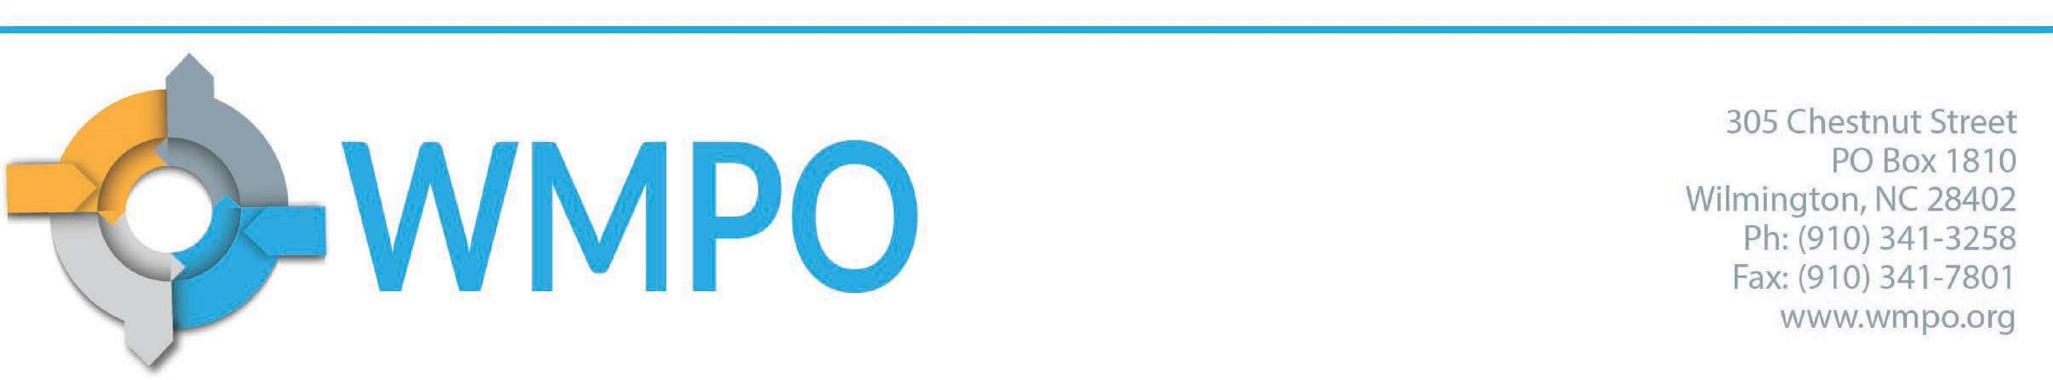

Meeting Minutes
Wilmington Urban Area Metropolitan Planning Organization Bicycle and Pedestrian Advisory Committee
October 11, 2022

Members Present:
Karin Mills, City of Wilmington
Carol Stein, Pender County
Rodney Kidd, Town of Carolina Beach
Katie Ryan, Town of Wrightsville Beach
Brianna D’Itri, Wave Transit
Joe Boyd, Town of Belville
Mo Linquist, Town of Kure Beach
Katie Ryan, Town of Wrightsville Beach
Al Schroetel, Cape Fear Cyclists
Steve Zinder, UNCW
Adrienne Cox, NCDOT Division 3
Terry Bozeman, New Hanover County
Emma Stogner, WMPO
Abby Lorenzo, WMPO

Staff and Guests Present
Carolyn Caggia, WMPO
Greer Shivers, WMPO

Call to Order
C. Stein called the meeting to order at 2:02 pm and roll was called.

Approval of the Agenda
Motion to approve was made by Al Schroetel Motion was seconded by Steve Zinder
Motion passed unanimously

Public Comment Period
There were no public comments.

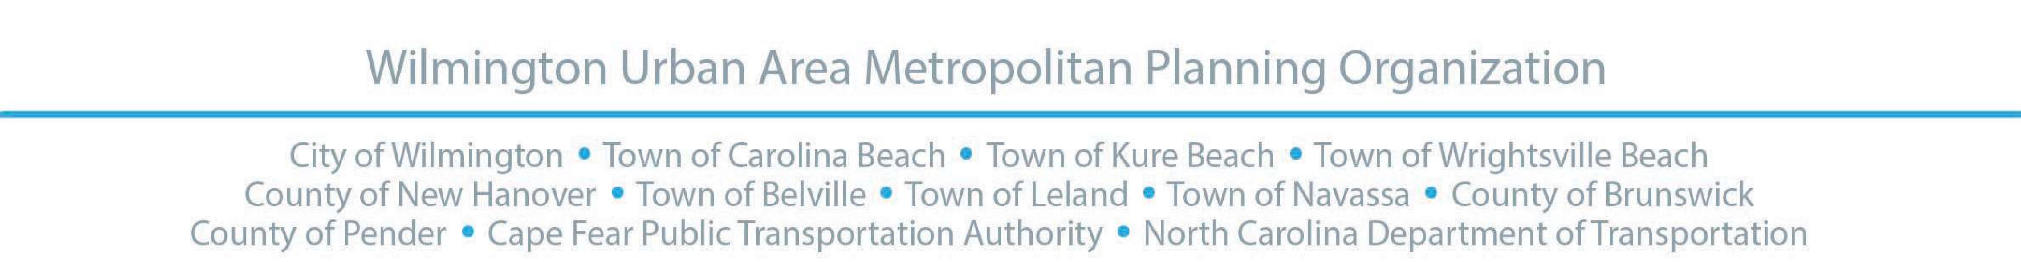

Approval of minutes from August 2022
Motion made to approve by Katie Ryan, seconded by Terry Bozeman
Motion passed unanimously

Presentations
Emma Stogner gave a presentation about the Gullah Geechee Heritage Corridor in Brunswick County, covering an overview of the corridor’s history and current planning efforts.
- Emma Stogner gave a presentation on current projects and initiatives relating to the East Coast Greenway.

Old Business
Emma Stogner shared that the Brunswick Heritage Riverside Ride had a total of 64 participants and that feedback from the event suggests that everything went smoothly for riders. There was a strong interest from participants to learn more about the corridor and efforts to preserve it.
- Greer Shivers shared an update on the East Coast Greenway signage initiative, sharing progress by the group. Greer fielded questions about the survey application and signage standards.

New Business
Emma Stogner shared the 2022 Commuter Challenge was ready to take place and encouraged members to share the news with their respective communities. She also shared that a dashboard would be available to track progress throughout the event.
- The committee discussed the virtual attendance policy of the group, arriving at a consensus to maintain a hybrid policy that allows for in-person interaction yet allows members to attend virtually when desired. Steve Zinder motioned to keep the current attendance policy; the motion was seconded by Karin Mills. The motion passed unanimously.

Updates and Announcements
Carol Stein shared that the BikeWalkNC summit would take place later in the month and encouraged members to attend.
Al Schroetel shared that Cape Fear Cyclists would host a pickup on October 22nd.
Abby Lorenzo shared that the WMPO’s Direct Attributable Program’s 2022 cycle awarded several bicycle and pedestrian construction projects.
- WMPO September Project Updates (in packet)
NCDOT Division 3 September Project Updates (in packet)
WMPO Technical Coordinating Committee, Wednesday, October 12, 2022, at 10am WMPO Board Meeting, Wednesday, April 27, 2022, at 3pm
Go Coast Committee, Thursday, October 26, at 3pm

Next Meeting
Tuesday, December 13, 2022, at 2PM

Adjournment
Motion to adjourn was made by Steve Zinder Motion was seconded by Katie Ryan
Motion passed unanimously

2

