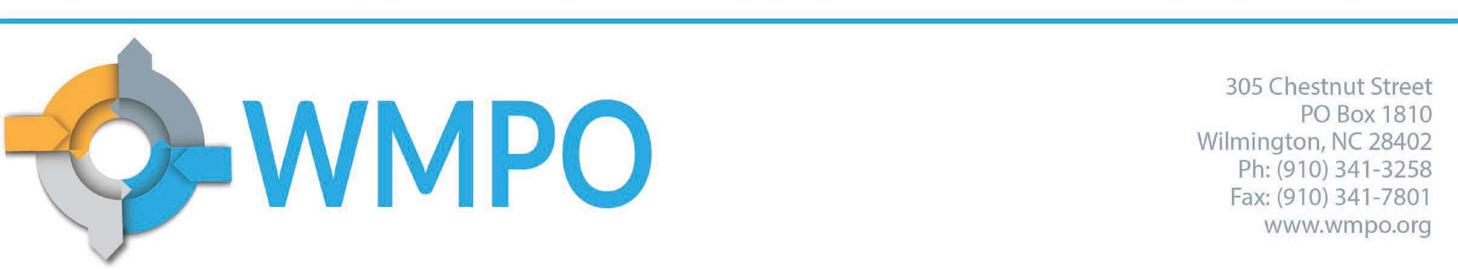

Meeting Minutes
Wilmington Urban Area Metropolitan Planning Organization Bicycle and Pedestrian Advisory Committee
December 13, 2022

Members Present:
Karin Mills, City of Wilmington
Carol Stein, Pender County
Rodney Kidd, Town of Carolina Beach
Katie Ryan, Town of Wrightsville Beach
Brianna D’Itri, Wave Transit
Mo Linquist, Town of Kure Beach
Vanessa Lacer, Town of Leland
Al Schroetel, Cape Fear Cyclists
Sam Burgess, Cape Fear Cyclists
Steve Zinder, UNCW
Emma Stogner, WMPO

Staff and Guests Present
Carolyn Caggia, WMPO
Greer Shviers, WMPO
Abie Bonevac, City of Wilmington
Greg Germain, Special Pedals

Call to Order
C. Stein called the meeting to order at 2:02 pm and roll was called.
- Greg Germain introduced himself and explained Special Pedal’s mission to improve safety for bicyclists and pedestrians while also focusing on special needs populations. He shared that Special Pedals is right down the road and that they would like to work with the BPAC in the future.

Approval of the Agenda
Motion to approve was made by Steve Zinder.
Motion was seconded by Mo Linquist.
Motion passed unanimously.

Public Comment Period
There were no public comments.

Approval of minutes from August 2022
Motion made to approve by Steve Zinder, seconded by Katie Ryan.
Motion passed unanimously.

Presentations
Emma Stogner gave a presentation about bicycle and pedestrian plans and projects that are planned to take place in 2023. Members of the committee asked that this list be updated regularly and sent out through email. Members also expressed the desire to share the list with the public to show constituents the progress being made for bicyclist and pedestrians. Emma shared some of the places that project information can be found.

Old Business
Emma Stogner shared with the committee that WMPO staff have been working on creating a volunteer opportunity for members but have run into a few barriers. Staff will continue to work on the task and bring an update back to the BPAC when they have one. Emma also said that she was going to speak with East Coast Greenway and Mountains to Sea Trail to see how they approached the issue.
- Carolyn Caggia shared updates about Year of the Trail and showed the committee the WMPO’s new story map for the endeavor. The committee requested that the story map be include in a follow-up email.
- Emma Stogner informed the committee that both of the WMPO’s applications to the NCDOT Feasibility Studies Grant Program were awarded. She also said that she would keep the committee in the loop as both plans progressed.

New Business
Mo Linquist shared information with the group regarding Bike Walk NC’s bicycle friendly driver program. Bike Walk NC is reaching out to specific counties to inform law enforcement and the public about bicycle and pedestrian safety. Emma Stogner suggested that the WMPO begin working with local law enforcement to promote the program.
- Carolyn Caggia shared local ordinances and general statutes that guide the regulation of electric bikes, however, there are few and inconsistent guidelines. The committee discussed safety in regards to electric bicycles, sharing that some local governments are looking for guidance on how to handle the trend.
- Emma Stogner announced the date for the next River to Sea Bike Ride and called for members to join the subcommittee to plan the event. Steve Zinder, Steve Whitney, Karin Mills, Mo Linquist, Sam Burgess, and Carol Stein volunteered. The committee talked about an event at the end of the ride to reward participants, but a location has not been established. Greg Germain shared that Special Pedals might be able to accommodate.
- Emma Stogner showed the committee the new web page on the WMPO’s web site specifically for BPAC. Steve Zinder suggested that the committee keep important documents on a shared drive. Emma Stogner replied that she will compose a shared location for the committee.

Updates and Announcements
Sam Burgess shared that the Tour de Blueberry will take place in June and encouraged members to be involved. Al Schroetel shared the Ride of Silence will be on June 17th to remember those who have died while bicycling.
WMPO Technical Coordinating Committee, Wednesday, March 15, 2023, at 10am WMPO Board Meeting, Wednesday, February 20, 2023, at 3pm
Go Coast Committee, Thursday, February 16, at 3pm

Next Meeting
Tuesday, April 11, 2023, at 2PM

Adjournment
Motion to adjourn was made by Steve Whitney. Motion was seconded by Steven Zinder.
Motion passed unanimously.

